[The Egyptian Journal of Remote Sensing and Space Sciences 24 (2021) 971–981](https://doi.org/10.1016/j.ejrs.2021.08.007)



Contents lists available at [ScienceDirect](http://www.sciencedirect.com/science/journal/11109823)

The Egyptian Journal of Remote Sensing and Space Sciences

journal homepage: [www.sciencedirect.com](http://www.sciencedirect.com/)

Review Article

Smart farming for improving agricultural management

Elsayed Said Mohamed a,⇑, AA. Belal a, Sameh Kotb Abd-Elmabod b, Mohammed A El-Shirbeny a, A. Gad a,

Mohamed B Zahran a

a *National Authority for Remote Sensing and Space Sciences (NARSS), Cairo 11843, Egypt*

b *Soils & Water Use Department, Agricultural and Biological Research Division, National Research Centre, Cairo 12622, Egypt*

a r t i c l e i n f o

*Article history:*

Received 8 June 2021

Revised 14 August 2021

Accepted 17 August 2021

Available online 6 September 2021

*Keyword:*

IoT

Smart Agriculture 5G

Decision support systems Smart sensing

a b s t r a c t

The food shortage and the population growth are the most challenges facing sustainable development worldwide. Advanced technologies such as artificial intelligence (AI), the Internet of Things (IoT), and the mobile internet can provide realistic solutions to the challenges that are facing the world. Therefore, this work focuses on the new approaches regarding smart farming (SF) from 2019 to 2021, where the work illustrates the data gathering, transmission, storage, analysis, and also, suitable solutions. IoT is one of the essential pillars in smart systems, as it connects sensor devices to perform various basic tasks. The smart irrigation system included those sensors for monitoring water level, irrigation efficiency, climate, etc. Smart irrigation is based on smart controllers and sensors as well as some mathematical relations. In addition, this work illustrated the application of unmanned aerial vehicles (UAV) and robots, where they can be achieved several functions such as harvesting, seedling, weed detection, irrigation, spraying of agricultural pests, livestock applications, etc. real-time using IoT, artificial intelligence (AI), deep learning (DL), machine learning (ML) and wireless communications. Moreover, this work demon- strates the importance of using a 5G mobile network in developing smart systems, as it leads to high- speed data transfer, up to 20 Gbps, and can link a large number of devices per square kilometer. Although the applications of smart farming in developing countries are facing several challenges, this work highlighted some approaches the smart farming. In addition, the implementation of Smart Decision Support Systems (SDSS) in developing countries supports the real-time analysis, mapping of soil characteristics and also helps to make proper decision management. Finally, smart agriculture in devel- oping countries needs more support from governments at the small farms and the private sector.

© 2021 National Authority for Remote Sensing and Space Sciences. Production and hosting by Elsevier B.

1. This is an open access article under the CC BY-NC-ND license ([http://creativecommons.org/licenses/by-](http://creativecommons.org/licenses/by-nc-nd/4.0/)

[nc-nd/4.0/](http://creativecommons.org/licenses/by-nc-nd/4.0/)).

Contents

* 1. Introduction 972
  2. The main pillars and methods of smart farming 973
  3. IoT in smart agriculture 973
  4. 5G network on smart farming 973
  5. Smart sensing for agriculture 974
  6. Application of IoT in smart farming 974
     1. IoT based for drones 974
  7. Limitations use of drones in agriculture 976
     1. IoT agricultural robot 976
  8. Smart farming approaches in developing countries 977
  9. Smart decision support systems (SDSS) 978
  10. Conclusions 979

Peer review under responsibility of National Authority for Remote Sensing and Space Sciences.

Given their role as Editor-in-Chief and editor, respectively, Prof. Mohamed B. Zahran and Prof. Abd-Alla Gad had no involvement in the peer review of this article and had no access to information regarding its peer review. Full responsibility for the editorial process for this article was delegated to Prof. Abdelazim Negm.

* Corresponding author.

*E-mail address:* [salama55@mail.ru](mailto:salama55@mail.ru) (E. Said Mohamed).

<https://doi.org/10.1016/j.ejrs.2021.08.007>

1110-9823/© 2021 National Authority for Remote Sensing and Space Sciences. Production and hosting by Elsevier B.V. This is an open access article under the CC BY-NC-ND license (<http://creativecommons.org/licenses/by-nc-nd/4.0/>).

Declaration of Competing Interest 980

References 980

1. Introduction

The increase in population growth is accompanied by an increase in demand for food production. The FAO reported that the world population would be reached 9.73 billion by 2050, and the increase will continue till reach 11.2 billion by 2100 (FAO, 2017).

Many challenges impede agricultural production, which leads to a decrease in crop productivity, such as soil salinity in arid con- ditions (Hammam & Mohamed, 2018; Mohamed et al.,2019b; Said et al.,2020; Abdel-Fattah et al.,2020). In addition, the climate also affects the quantity and quality of crops and may lead to an increase in soil sensitivity to desertification (Mohamed et al., 2013; Mohamed et al.,2014; El-Zeiny et al.,2017; Abdel-Fattah et al.,2021). Therefore, the focus on survey land resources to use in agricultural development in arid regions is necessary (ElNahry & Mohamed, 2011; Saleh et al., 2015; Hassan et al., 2019). In devel- oping world countries, the agricultural sector is one of the most important pillars of national income. Therefore, implementing new technologies to improve the agricultural sector is a significant issue for supporting the national economy in those countries (Mohamed et al., 2016; Nyaga et al., 2021). Agricultural production includes the production of food for humans and livestock, in addi- tion to the raw materials needed for the industrial process. Since the ancient time till now, there are several agricultural develop- ment revolutions; the first agricultural revolution was by Egyptian and Greek ancient civilizations that had reflected interesting of the ancient people in the development of agricultural methods, where papyri indicating the develop irrigation systems from more than 6000 BCE. Egyptians and Greeks developed several agricultural machinery and equipment, for example, tympanum, pumps, Sha- douf, and Sakai (Ahmed et al., 2020). The second agricultural revo- lution was showed during the 17th century that followed the end of feudalism in the continent of Europe.

Furthermore, the third agricultural revolution (Green Revolu-

tion) had activated during 1930–1960 of the last century, where an expansion uses of mineral fertilizers to increase agricultural production, as well as increased usage of pesticides parallel with the development of various agricultural machinery (Bochtis et al., 2019). The fourth agricultural revolution occurred during the past two decades, which there was a significant development in infor- mation communication technology (ICT) and AI. These technolo- gies have facilitated controlling the equipment and devices remotely, where robots have been used in agricultural operations such as harvesting and weeding, and also drones have also been used to fertilize crops and monitor crop growth stages.

Smart agriculture is a technology that relies on its implementa- tion on the use of AI and IoT in cyber-physical farm management (Bacco et al., 2019). Smart agriculture addresses many issues related to crop production as it allows monitoring of the changes of climate factors, soil characteristics, soil moisture, etc. The Inter- net of Things (IoT) technology is able to link various remote sen- sors such as robots, ground sensors, and drones, as this technology allows devices to be linked together using the internet to be operated automatically (AlMetwally et al., 2020). The main idea of precision agriculture is improving the spatial management practices to increase crop production on the one hand and avoid the misuse of fertilizers and pesticides on the other hand (Amato et al.,2015 Effat & El-zeiny, 2017).

Numerous research has been conducted on applying ANN mod-

els in smart irrigation water management (SIWM). The estimation of reference evapotranspiration (ETo) is one of the essential param- eters for crop irrigation because it determines irrigation scheduling

(Cruz-Blanco et al., 2014). The Penman-Monteith (PM) model is the most often used for estimating evapotranspiration, although it needs a large amount of data for accurate ET estimates. (2018, Shitu et al.) Because GIS is linked with remote sensing, artificial intelligence, GPS technology, and other technologies, it may con- serve a significant quantity of water that would otherwise be needed for irrigation. Mohd et al. (2014) created SWAMP (Soil Water Management for Paddies); a web-based Geospatial Decision

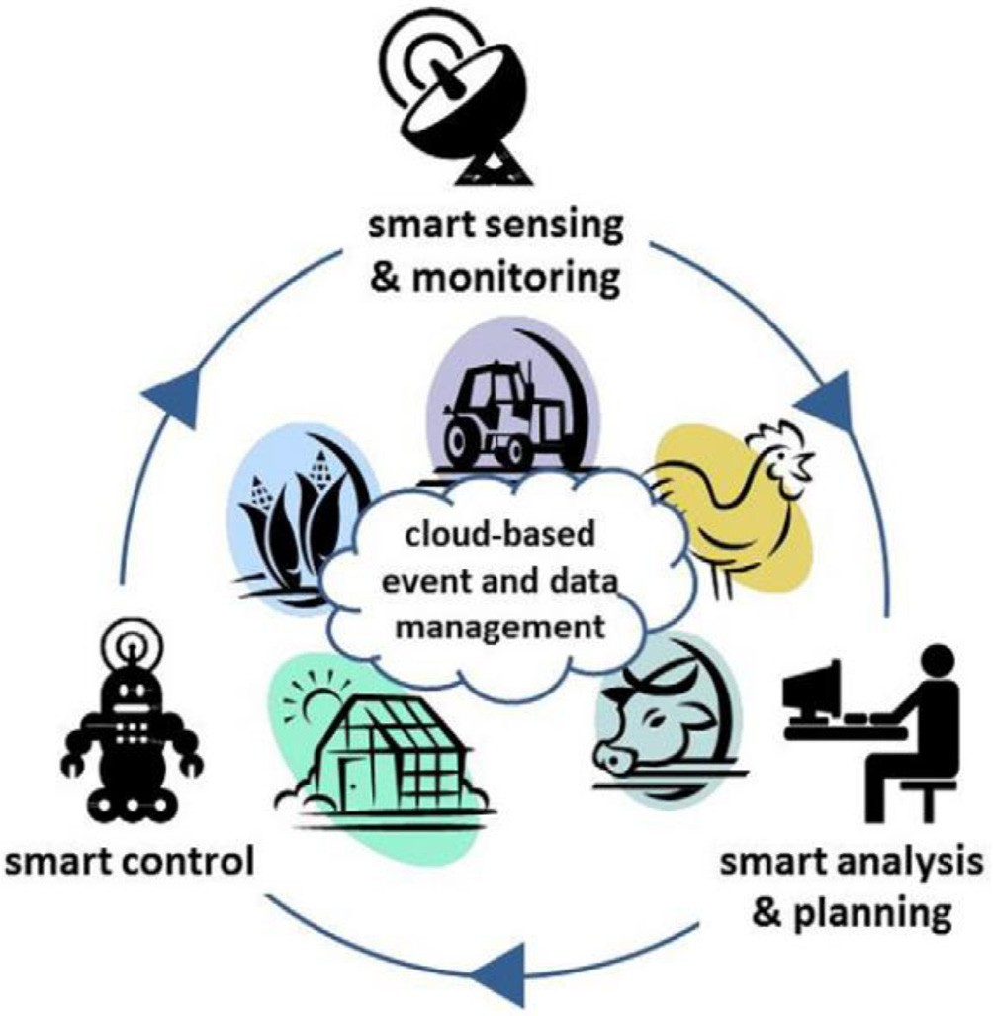

Fig. 1. Smart farming cycle (Wolfert et al., 2014).

Support System (DSS); and a graphical user interface (GUI) based on widget technology for simple access to different views for the rice IWM Scheme. The system offers data on irrigation water demand and supply, as well as irrigation efficiency and a water productivity index. One of the most significant aspects of this sys- tem is providing real-time information by visualizing the pre- sented results. Climate-Smart Agriculture (CSA) was created to address three key issues: food security, adaptation, and mitigation (Palombi & Sessa, 2013). CSA has received much interest, particu- larly in developing countries, because of its potential to improve food security and farm system resilience while lowering green- house gas emissions (Palombi & Sessa, 2013). This is particularly important in Africa, where economic development is based on agri- cultural expansion, which is the most susceptible to climate change (Vermeulen et al., 2012). Smart Agriculture is an evolution of precision agriculture by innovating smart methods to achieve multifunctional regarding the farm management remotely sup- ported by alternatives appropriate solutions of farm management in real-time. Fig. 1 showed that robots could fulfill essential roles in controlling the agricultural process and anticipate automatic analysis and planning so that the electronic cyber-physical cycle becomes semi-autonomous (Wolfert et al., 2014). European Union (EU), highlighted the technologies importance of high-resolution satellite images, Unmanned Aerial Vehicles (UAVs), agricultural robots, and sensor nodes to collect data that could be integrated into future strategies of European agriculture smart farming signed in April 2019 by 24 EU countries (Bacco et al., 2019). Parallel to expanding the various sensing methods for collecting, processing,

and analyzing data, the volume of data used in agricultural man- agement has become very big. Thus this leads to a decrease in the ability of the 4G network to connect all components of the smart network in remote locations. Recently, after the operation of the ultra-fast 5G switch, the process of transferring and process- ing data has become easy (Tang et al., 2021).

Smart agriculture technology based on the Internet of Things (IoT) technologies has many advantages related to all agricultural processes and practices in real-time, which include irrigation and plant protection, improving product quality, fertilization process control, and disease prediction, etc.(Adamides et al., 2020).

The advantages of smart agriculture can be summarized as fol- lows: 1) Increasing the amount of real-time data on the crop, 2) Remote monitoring and controlling of farmers, 3) Controlling water and other natural resources, 4) Improving livestock manage- ment, 5)Accurate evaluation of soil and crops; 6)Improving agricul- tural production.

This work aims to review published articles on the techniques above with regards to smart farming, in addition, highlight some approaches to smart farming in developing countries

1. The main pillars and methods of smart farming

The current work considered a large number of research topics to explore scientific methods relating to smart farming. Conse- quently, this work covered many aspects regarding the agricultural practices, decision-making, and technologies involved. We have used several sources from various scientific publishers such as Springer, Elsevier, Wiley, MDPI, etc. The sources varied from books, book chapters, conference proceedings, and articles, in addition to research project reports. Thus, this work has relied on 58 published documents, most of which were published during the last three years, and the authors from different countries worldwide. Mean- while, a particular focus was dedicated to some smart agriculture approaches in the Africa continent. Subsequently, the review high- lights the main components of smart farming, such as IoT, the role of internet connection, and smart sensing.

1. IoT in smart agriculture

The Internet of Things (IoT) is an intelligent and promising tech- nology that offers unconventional and practical solutions in many areas, as shown in Fig. 2, such as smart cities, smart homes, traffic

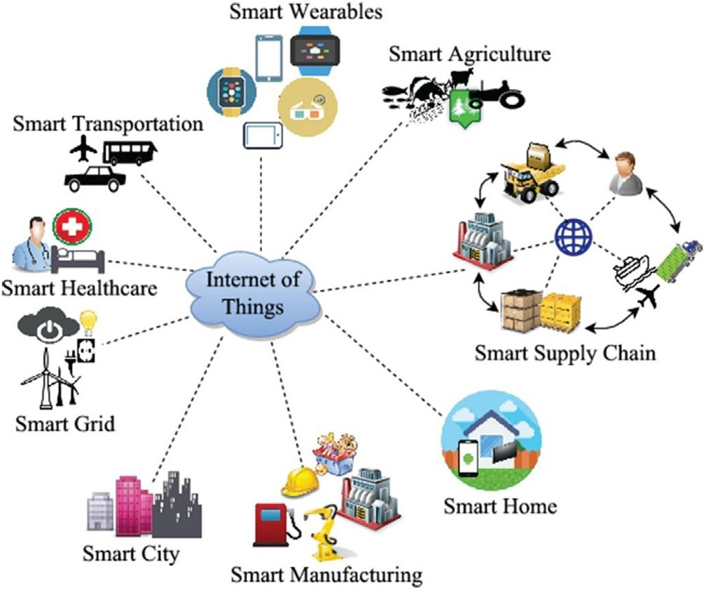

Fig. 2. Application of IoT in different areas (Samaila et al., 2018).

control, healthcare, smart agriculture, etc. In the agricultural field, IoT technology has made significant development in agricultural management. This technology allows all agricultural devices and equipment is to be linked together to make the appropriate deci- sion in irrigation and fertilizer supply (Kumar & Periasamy, 2021). The smart systems enhance the accuracy efficiency of devices that monitoring plant growth and even raising livestock. Wireless sensor networks (WSNs) are used to collect data from dif- ferent sensing devices. In addition, cloud services are also essential to be integrated with IoT to analyze and process the remote data that facilitates decision-making to implement the best decisions (Farooq et al., 2020). Smart farm management requires using ICT, ground sensors, and control systems installed on robots, autono- mous vehicles, and other automated devices. The success of smart systems depends on high-speed internet, advanced mobile devices, and satellites to provide (images and positioning). James et al. (2019) succeed used IoT real-time to track and diagnose leaf dis- eases that obstruct crop growth using many satellite images and sensors positioned in farms (paddy and banana crops); this system helped to be analyzed the data and made the decision then sent back to the farmers Via the webserver.

. According to the report of the Food and Agriculture Organiza-

tion (FAO 2017), about 20–40% of crops are lost annually due to pests and diseases and as a result of lack of good monitoring of the state of the crop. Hence, the use of sensors and smart systems allows monitoring of weather factors, fertility status, and also determining the exact amount of fertilizers necessary for crop growth. The excessive use of fertilizers has adverse effects on soil fertility. Farooq et al. (2020) surveyed 67 research papers that pub- lished through 2006 to 2019 on the use of IoT in different agricul- tural applications; they noted that about 16% of the research papers were on precision agricultural and also 16 % on irrigation monitoring,13% on soil monitoring, 12% on temperature, Animal monitoring and Humidity monitoring were 11% for each, air and diseases monitoring were 5% for each in addition to water monitor- ing was 7 %. Finally, fertilization monitoring was only 4% of the research papers Fig. 3.

1. 5G network on smart farming

Parallel with the development in smart systems, communica- tion and information technology has also undergone significant development in the few years. During the past ten years, the 3G / 4G / NB-IoT wireless network technology provides an adequate speed for transmitting information and communication, is used to connect smart devices through the IoT to share data for accurate evaluation in the agricultural field. However, with the develop- ment in the quantity and quality of information, the efficiency of the 4G network has decreased, as the data transmission has become weak compared to before that. The 5G network expresses the evolution of the fifth-generation communication networks to provide a very high speed to transform data in low time (Sutton et al., 2018). The data transfer using the 5G network is faster than other networks as it increases by nearly 100 times in download and upload speeds in the 4G network. This means downloading a 2-hour movie would take less than four seconds on 5G compared to 6 min on 4G. in addition, 5G network characterized by 10Gbps, the downlink rate is 20Gbps (Anand et al., 2020).

There are many advantages of using a 5G network in smart

applications as follows:

* High data transfer capacity, low latency
* Very high connection density compared to another network.
* Spectral efficiency improvement.
* Smooth communication performance.

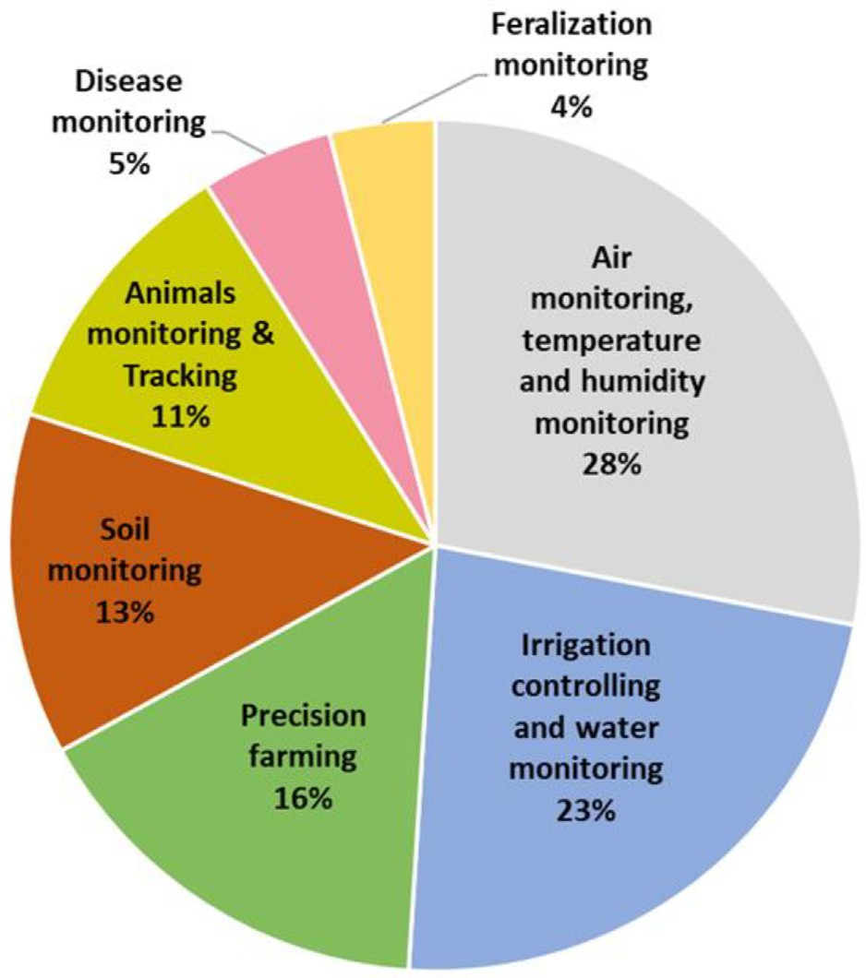

Fig. 3. Application of IoT on smart Agricultural. (Adapted from Farooq et al., 2020)

* Extensive coverage.
* High efficiency of network energy.

The spatial distribution map shows that the United States, Canada, some countries in Europe, Australia, China, and Japan are the countries that use the 5G network around the world, as shown in Fig. 4 (Ookla, 2020). Studies show that about 80% of the rural population in the UK is still outside the 4G band, which affects the application of advanced smart technology in rural areas (USDA, 2019).

In 2017, 5G was used for the first time in smart farming appli- cations such as crop harvesting, fertilization, pesticides, and seed operations through autonomous tractors and drones. In addition, 5G has positive impacts on the agricultural sector where improve severs agricultural operations such as drone control, interactive real-time monitoring, seeding operations, pesticide, and fertilizer spraying, artificial intelligence robots, and data analytics Fig. 5.

1. Smart sensing for agriculture

Sensors are responsible for measuring and monitoring all fac- tors in the smart system; for example, soil health monitoring has special sensors such as nutrients contents, phosphate con- tents, soil moisture, and compaction and so on. The smart irriga- tion system included many sensors for monitoring water levels, irrigation efficiency, climate sensors, etc. The sensors can measure and monitor the changes in soil and yield properties and local weather on-farm sites. So, the sensors can gather the different data to be used for the analysis of the farm statutes and for mak- ing a suitable decision. These smart sensors monitor the variation in soil, crop, livestock health, in addition, contribute to enhance the agricultural product in terms of quantity and quality. The standard sensors used in smart farming networks are soil mois- ture sensors that use to measure the change in soil moisture, soil temperature used to measure the monitor the temperature in soil, air temperature, soil pH value, humidity, N, P, K sensors, etc. (Kumar et al., 2021).

Figs. 6 and 7 showed several applications of sensors in smart

agricultural management such as; smart irrigation, leaf disease identification, improving crop yield and harvesting and also smart animal husbandry, etc. Each application contains relevant factors effects.

1. Application of IoT in smart farming

Smart systems are associated mainly with IoT, as it represents the backbone in all smart applications; the most important appli- cations of IoT smart farming are as follow:

* 1. *IoT based for drones*

Drones have been used commercially in agriculture since the early 1980 s in limited use, but with the development of commu- nication technology and the expanded use of IoT, the use of unmanned aircraft has become very important. It can perform numerous functions that lead to improving agricultural practices. Examples of drone operations are irrigation, monitoring crop health, planting, crop spraying, crop inspection, and soil analysis. In addition, the drone equipped with several sensors,3D cameras, thermal, multi-spectral, and optical imaging cameras can be used to monitor crop conditions and diseases, plant health indicators, vegetable density, pesticide prospecting, fertilizer, canopy cover

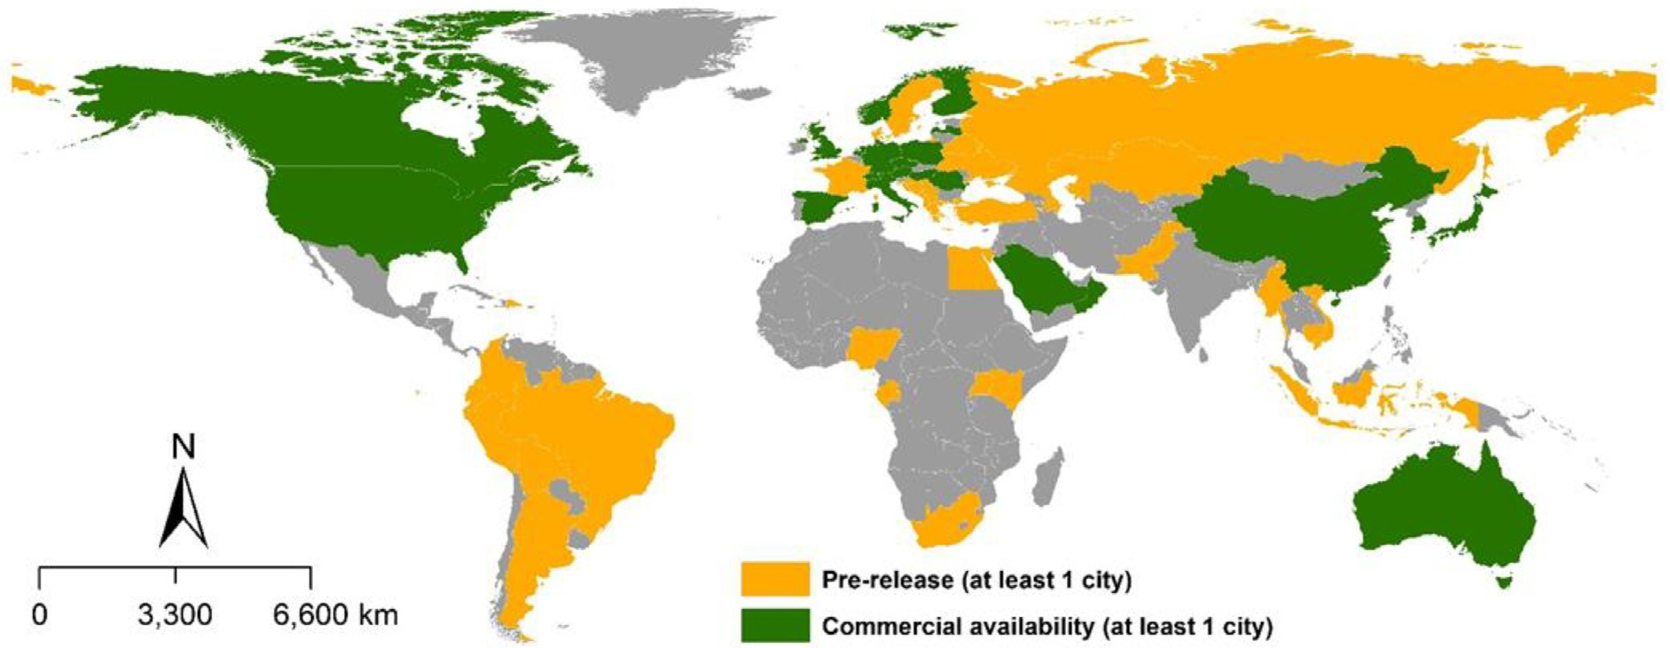

Fig. 4. Spatial distribution map of 5G (Adapted from Ookla, 2020).

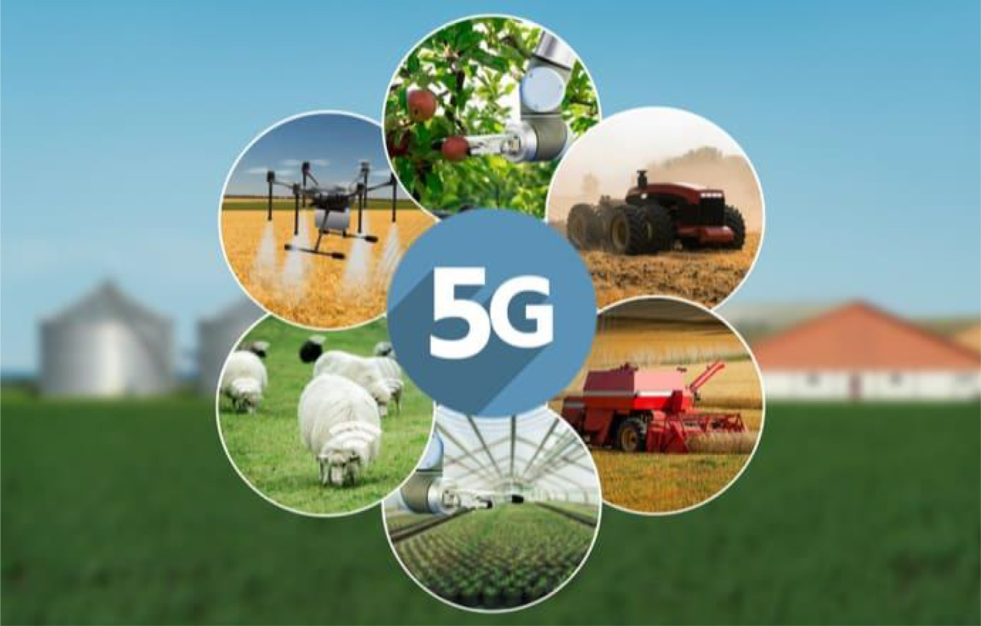

Fig. 5. Application of 5G in Agricultural (Farming Paradise, 2020; <https://farmingparadise.com/5g-future-farming>)

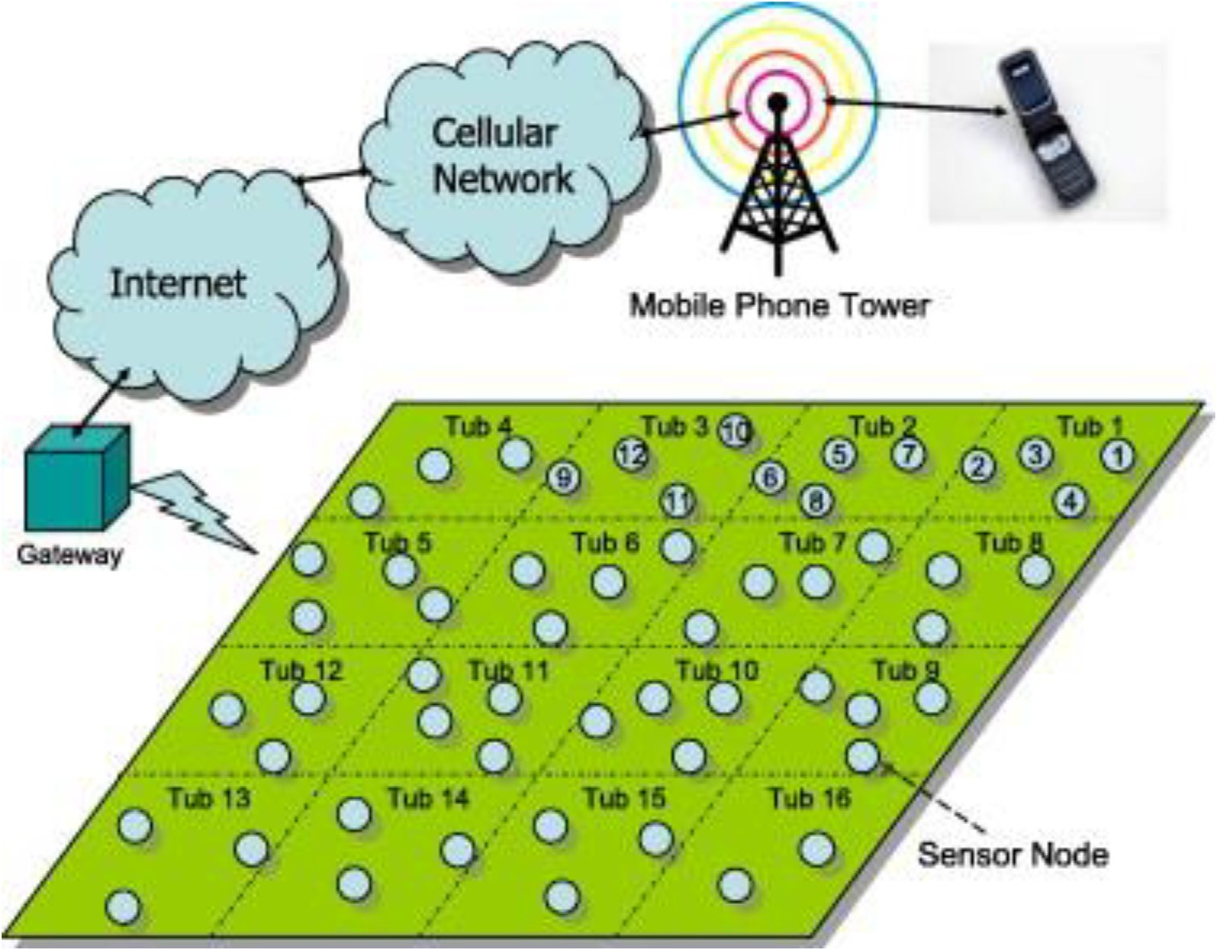

Fig. 6. Automated Wireless smart Sensors (Kumar et al., 2021).

mapping, field prediction, plant count, plant height measurement, field water mapping, exploratory reports, nitrogen measurement (Islam et al., 2021). Furthermore, it can monitor the state of plants

based on some vegetative indices that can be directly calculated by multi-spectral images, such as the Normalized Difference Vegeta- tion Index (NDVI), which is considered one of the most famous.

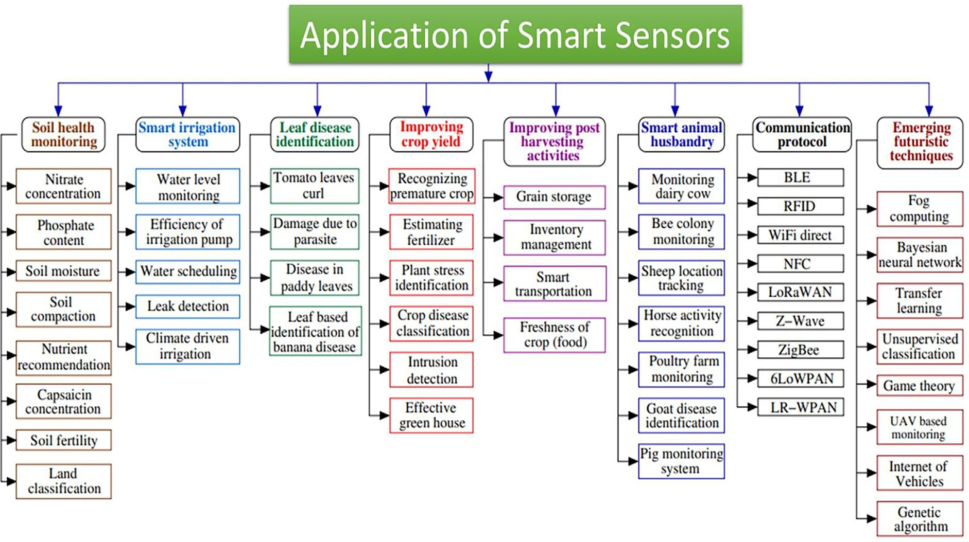

Fig. 7. Application of smart sensors in agriculture (Kumar et al., 2021).

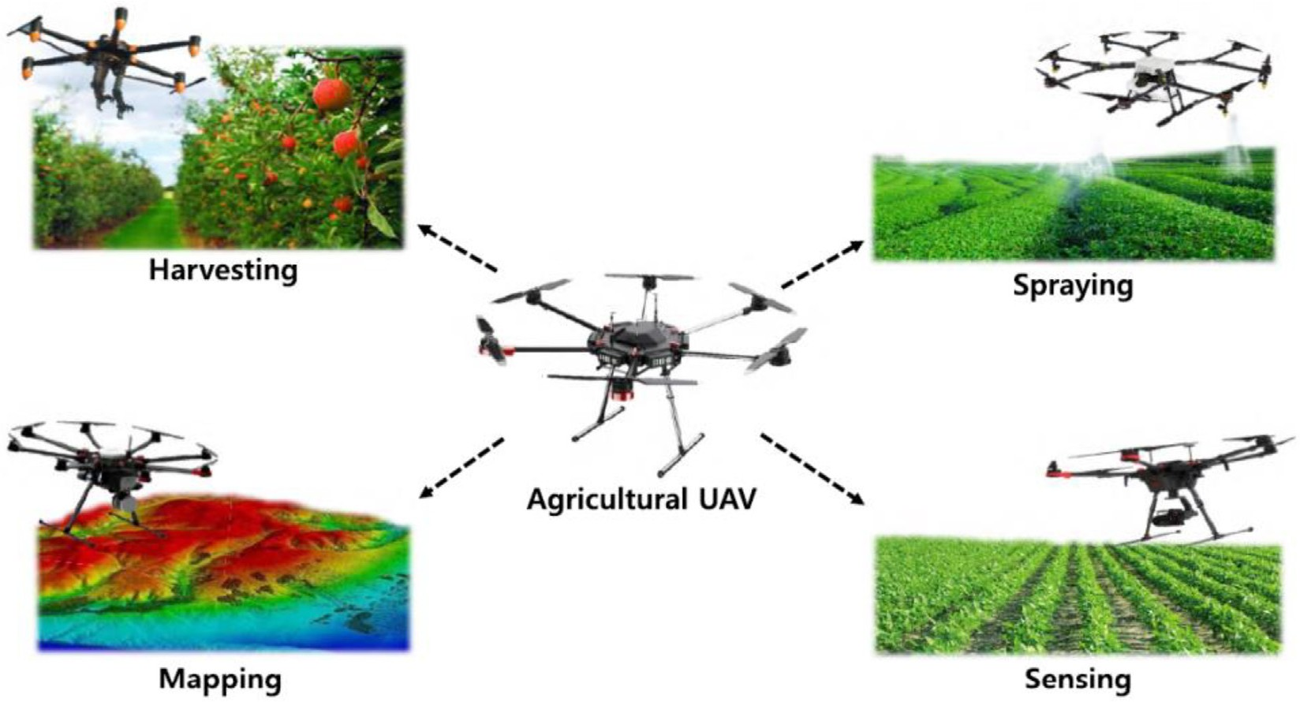

Fig. 8. Usage of UVAs for agricultural UAVs (Harvesting UAV, Spraying UAV, Mapping UAV, Sensing UAV (Kim et al., 2019).

Kim et al. (2019) showed the different applications of UAVs (Harvesting, Spraying, Mapping, Sensing UAV). Fig. 8 shows the impacts of drones on agricultural development by using real- time data collection and processing.

1. Limitations use of drones in agriculture

Despite the many benefits of using unmanned aircraft, signifi- cant challenges are facing its use, , especially in developing coun- tries (Ayamga et al., 2021) as follow:

The drone can fly for a short time, reaching an hour or less; therefore, the flight line path must also be determined consider- ing the overlap between the flight lines.

●

Drones cost expensive, especially those with good software, hardware tools, devices, high-resolution cameras, and thermal cameras.

Laws to operate drones: Drone needs permits for the operation; this is difficult in many countries, as well as the height of the pilot must not exceed 400 feet.

●

●

Climate impact: the operation of drones is affected by climatic conditions. The wind speed and rains affect the drone perfor- mance, so the weather must be considered before work.

●

* 1. *IoT agricultural robot*

The agricultural robot is a robot used in many agricultural prac- tices. IoT has contributed to the development of robots to be

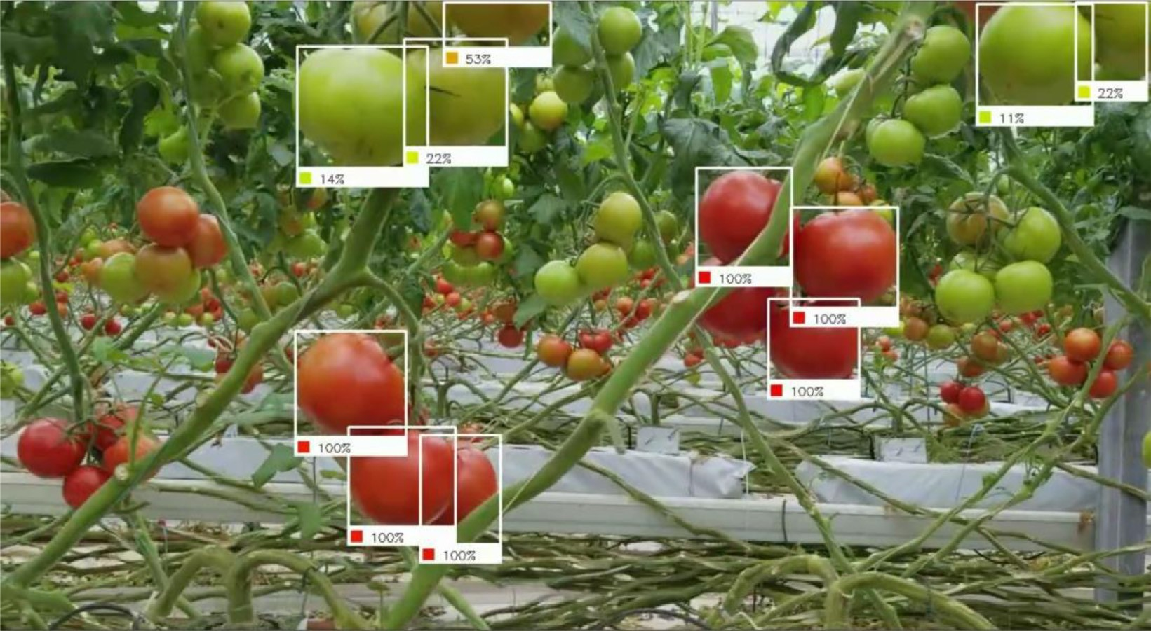

Fig. 9. Tomato harvesting by Robots (Postscapes 2020. ,[https://www.postscapes.com/agriculture-robots/#autosteering](https://www.postscapes.com/agriculture-robots/%23autosteering)).

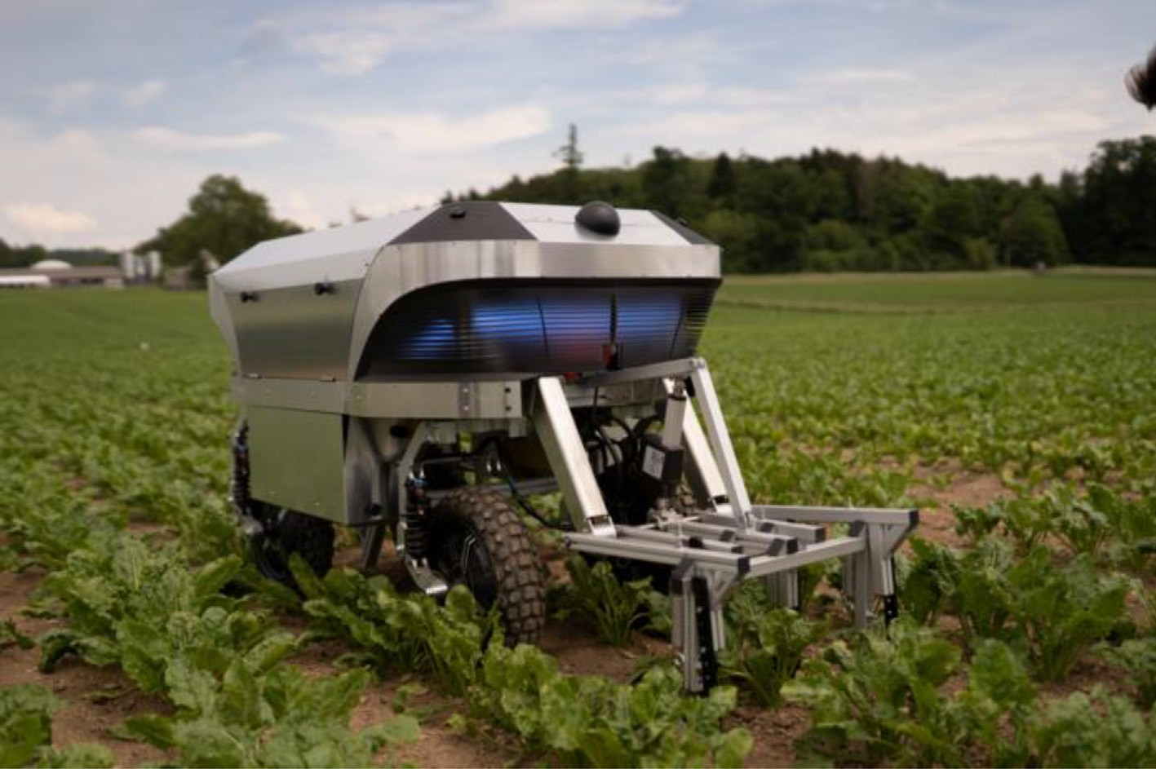

Fig. 10. An autonomous agricultural robot for weed removal uses.

achieved multiple agricultural activities, where robots can perform many functions instead of humans. In the US and Europe and many countries in Asia, they extended to the use of such modern technol- ogy in agriculture, where robots have improved agriculture effi- ciency, as they reduced operating costs and reduced operating time (Kootstra et al., 2021). In addition, the robots can reduce the environmental pollution of up to 80% of farm’s pesticides. Agri- cultural robots will be practical tools to provide unconventional solutions for smart agriculture to face labor shortages, especially in the spread of diseases such as the Covid 19. Several agricultural robots, such as robots for harvesting, seedling, weed detection, irri- gation, and pest infestation, livestock applications, etc., each robot can do one or more functions, as shown in Figs. 9 and 10 (Darwin et al.,2021).

Chand et al. (2021) succeeded in designing a multi-purpose

smart farm robot (MpSFR) that can carry out water sprinkling

and pesticide spraying based on IoT and computer vision (CV) tech- nology, as well as the system depends on the use of photovoltaic (PV) energy that works with a battery. The authors confirmed that the robot works automatically, provided with a water tank and another for pesticides; the mechanism of robot action depends on the sensors that track crop health using infrared radiation. The robot can cover an area of 5 m. Moreover, robots have been used successfully in several industries applications, for example, quality control, material handling, transportation, processing, and inspection.

1. Smart farming approaches in developing countries

The implementation of SF technology is considered very impor- tant around the globe, and the developing countries are interested

in localized such technology (Arslan et al., 2015; Senyolo et al., 2018). The developing countries have several challenges in imple- menting smart systems regarding the availability of infrastructure owned by the state and other capabilities possessed by individuals (Glaroudis et al., 2020). Therefore, the obstacles to the implemen- tation of smart agricultural technology in developing countries can be summarized as follows;1) The availability of a suitable network of the fourth or fifth generation and is the most crucial factor in terms of data transmission between sensors via the Internet.2) The availability of sensors as they are responsible for measuring the various phenomena and characteristics on the farm.3) Avail- ability of devices and equipment that can achieve agricultural operations.4) trained experts based on smart farms. However, their several approaches in the developing countries, in India, several factors affect the majority of farmers regarding the implementa- tion of smart farming technology such as weak socio-economic backgrounds and face many challenges due increasing cost of cul- tivation. Furthermore, one of the significant natural problems influencing agricultural productivity is climate change (Srivastava and Singh,2016). The same authors used GIS-based integrated modeling, which incorporates soil moisture accounting and irriga- tion water demand modules, rainfall-runoff modules, system loss modules, and groundwater flow system modules.

These challenges need concrete strategies at different levels,

from local to national levels. Climate-Smart Agriculture (CSA) has the potentiality to overcome those challenges (Lipper et al., 2014). (Doyle et al., 2018) innovated a methodology concerning the implementation of smart systems such as CSA to mitigate the effects of climate change in East Africa and also to reduce food insecurity at the local level, where they designed an aquaculture system to maximize the water use efficiency in irrigation-based aquatic crops. Moreover, they reuse the same water for a fish farm. This system adopts more efficient use of water for irrigation of crops compared to traditional agriculture, making it more resistant to drought and desertification, and also contributes to reducing cli- mate impacts in rural areas in East Africa. There was another expe- rience in South Africa to use smart irrigation based on Climate- smart agricultural technological at the farm level to address cli- mate challenges. In Africa, smart technology faces many obstacles such as the farm areas, which their areas are ranging between 0.5 and 2 ha, climate, and environmental changes as well as water scarcity (Senyolo et al., 2018). In Ghana, drones are used econom- ically by renting these drones to monitor the crop health, then add- ing pesticides according to the need of the crop, which reduces

pollution and health risks, as shown in Fig. 11. Reducing the use of pesticides had a positive impact on the export of African prod- ucts in Europe.

A research team of the National Authority for remote sensing and space sciences (NARSS) (Belal et al.,2020) succussed develop- ing a reliable, robust, cost-effective, and scalable smart farming solution based on IoT technology. This system is accessible to mea- sure soil characteristics such as soil salinity, soil moisture, soil pH, and soil temperature. Soil temperature and moisture assessment are the most important criteria affecting the irrigation process (Abu-Hashim et al., 2015; Abd-Elmabod et al., 2019). This system is using very little power. Thus it can be used in rural areas. The output system is displayed on LCD, mobile applications, and inter- net websites. A web application is designed to collect sent data from the GSM module for analysis and documentation purposes. The linking between sensors and gateway is based on many proto- cols, for example, message queuing telemetry transport (MQTT) (Alqinsi et al., 2018). The collected data are storing in a database (MYSQL, NoSQL, etc.) or cloud platform. Machine learning and arti- ficial intelligence, deep learning, or big data analytics are used for decision-making purposes (Terence et al., 2020). The web applica- tion is installed on a server to collect and store the data for a long time, where these data can be downloaded as excel sheets or doc- ument files. The web recording the node number, date, and time of data receiving, then some columns for signals from sensors. The board can be programmed to read data from the sensor for a repeated user request (Choudhary et al., 2016).

1. Smart decision support systems (SDSS)

The implementation of Smart Decision Support Systems (SDSS) in the agriculture sector aims to support farmers and those inter- ested in agricultural investment for making proper decision- making (Adebayo et al., 2018). The decision support systems in agricultural management are numerous such as irrigation manage- ment, fertilization, and others for service operations (Ghosh et al., 2014). In addition, Giusti and Marsili-Libelli (2015) proposed a fuzzy decision support system for irrigation management, as the system includes spatial location data and crop characteristics in terms of crop growth stages, planting date and water require- ments, precipitation, temperature, as well as soil characteristics and water holding capacity. It also includes an inference system that determines irrigation timing to maintain soil moisture within

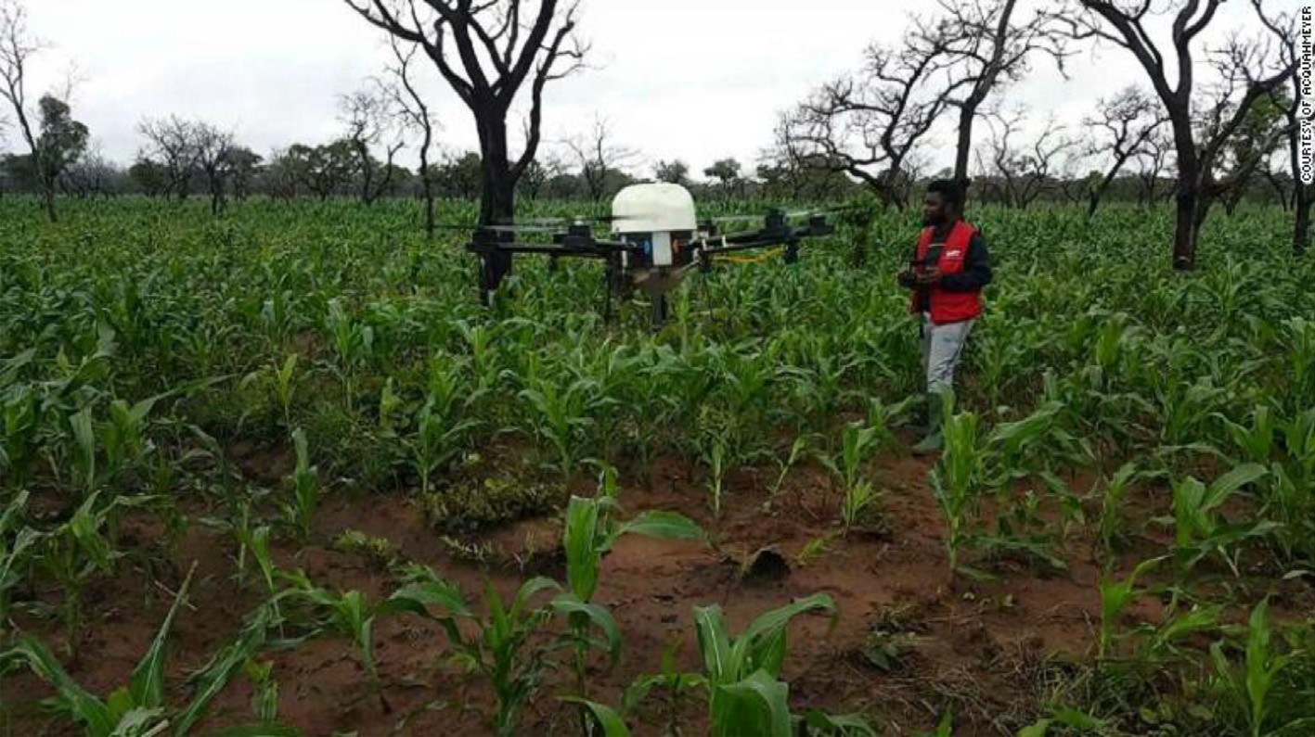

Fig. 11. Drones check leaf color and soil quality (Festus Annor-Frempong and Selorm Akaba, 2020).

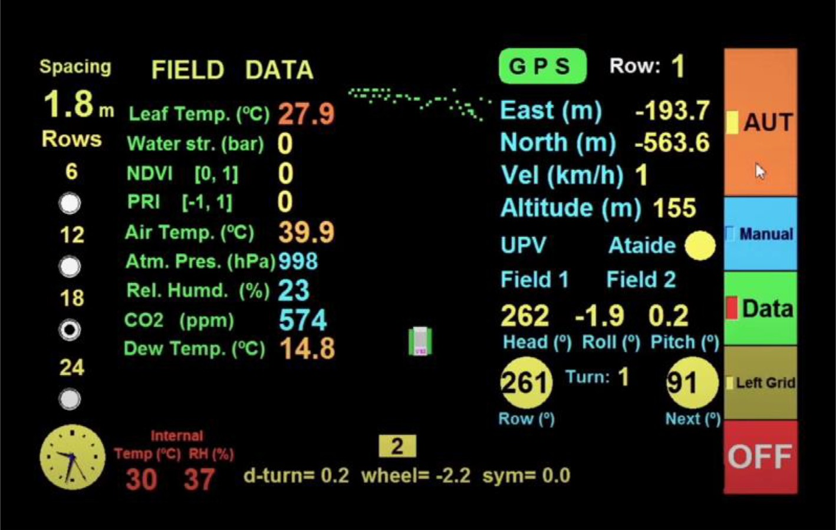

Fig. 12. Graphical user interfaces (GUI) for agricultural DSS.

the appropriate limits; this system has positive impacts in terms of water use efficiency and quality of crop yield. Based on the impor- tance of relying on geospatial data by using spatial geographic information systems to improve agricultural management, using artificial intelligence to implement the decision-making support system. VineScout has developed a graphical user interface (GUI) for agricultural DSS, as shown in Fig. 12 (Rovira, 2019). This system can be installed to the Robot system to achieve several functions in the farm; the GUI system included several geospatial data based. SDSS for agricultural applications is quite complex; it requires knowledge from various multidisciplinary areas, such as crop agronomy, computer hardware and software, mathematics, and statistics. For example, to understand crop growth, it is necessary to know how many variables affect crop growth, how each variable affects crop growth? Each crop requires a different optimum value for growth (Fields et al., 2020).

DSS model was developed to support decision-making in West

Africa to help local managers assess the Water Energy Food Envi- ronment, furthermore, proposing ideal administration answers for add to expanding the creation of food crops at the territorial level in the transboundary Mékrou stream bowl in the waterway bowl between Benin, Burkina Faso, and Niger. They supported crop productivity at the regional level for intensifying agricultural prac- tices, enhancing inputs such as nutrient fertilizers and water irriga- tion, etc. (Udias et al.,2018). The authors showed that this DSS could coordinate a few models, for example, a biophysical agricul- tural model, a simplified regression metamodel, linking crop pro- duction with external inputs, a linear programming and a multi- objective genetic algorithm optimization routines for finding effi- cient agricultural strategies; and a user-friendly interface for input/output analysis and visualization Fig. 13.

NARSS team (Mohamed et al., 2020) succeed in developing soft-

ware to enhance farm management under Egyptian conditions based on IoT technologies; this software is semi-automated in the first version as it can receive the data from two sources from exile sheet or based on IoT. The software can achieve numerous functions such as farm management zone (FMZ), spatial mapping analysis of soil characteristics, and agricultural-dedicated solu- tions. The smart management program should be flexible in mod- ifying modeling equations, parameter values, adding and removing elements, and it should contain alternatives solutions that address

a wide range of different phenomena in the field. IoT technology and web services are used to improve the automation of data col- lection with higher Spatio-temporal accuracy to facilitate and improve the decision-making process. The software provides some services to the users, including an absolute mapping service, real- time visualization of data, spatial analysis using virtual coordi- nates. The spatial interpolation and mapping could be achieved using Inverse distance weighting (IDW) based on the data collected from nodes locating in the field. The software can also illustrate a contours map that showed the distribution range of each phe- nomenon and also can be generated grid values dividing the field into zones of predefined ranges of the selected parameter; each range indicates a specific meaning or requires a different manage- ment criterion. When the quality index parameter is selected to be analyzed, also a legend indicates the quality classes of different land zones appears. The real-time data is used together with the stored laboratory data to analyze and evaluate the properties of soil, yield, and other factors regarding farm management. Thus the ranges that have the same symmetric range are thus identified and require spatial management (Gupta et al., 2020). The gauges visualization is used to visualize the phenomena used for soil parameters analysis for different nodes (regions) and show the analysis result in real-time.

1. Conclusions

The current work illustrated the importance of smart agricul- ture on improving and increasing agricultural production in order to contribute to reducing the food demand gap. IoT is considered the backbone of smart agricultural technology, as it connects all components of smart systems, not only in the agricultural field but also the other applications. Concerning the use of IoT in agri- culture, it can be used in many practices such as farm monitoring, irrigation, pest control, harvesting, etc. IoT connects several sen- sors with processing units, then analyzes data, then makes appro- priate decisions in real-time. This work reviewed the application of integration IoT with UAV and Robots systems controlled by AI techniques and the limitations of their use in developing countries. Recently, the success of SF performance is related to the speed of data transfer. Hence, the 5G network brought about the smart

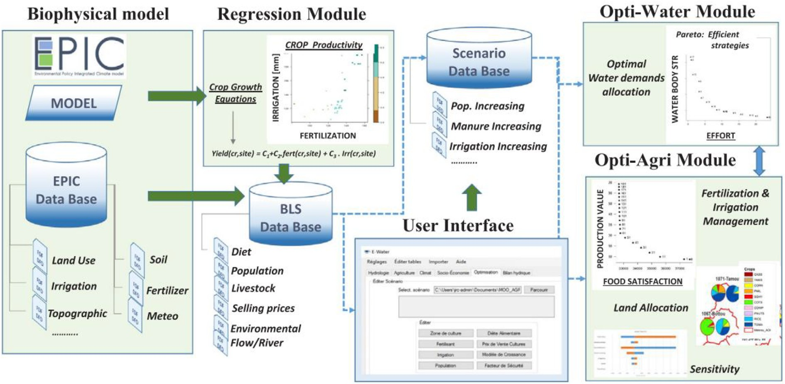

Fig. 13. DSS Schematic in west Africa (Udias et al., 2018).

agriculture field and provided flexible and efficient solutions, as a very high speed characterizes it compared to the fourth- generation networks. The application of smart agricultural tech- nology helps developing countries, such as some Egyptian approaches that represent the beginning toward the spread of such technology and can help develop the agriculture sector and achieve farm sustainability in those countries. Finally, these smart tech- nologies should be supported by governments in third world coun- tries at the level of small farms, as they aim to increase production and improve the efficient use of land and water resource.

Declaration of Competing Interest

The authors declare that they have no known competing finan- cial interests or personal relationships that could have appeared to influence the work reported in this paper.

References

[Abu-hashim, M., Mohamed, E., Belal, A.-E., 2015. Identification of potential soil](http://refhub.elsevier.com/S1110-9823(21)00058-2/h0005) [water retention using hydric numerical model at arid regions by land-use](http://refhub.elsevier.com/S1110-9823(21)00058-2/h0005) [changes. International Soil and Water Conservation Research 3 (4), 305–315](http://refhub.elsevier.com/S1110-9823(21)00058-2/h0005).

[Abdel-Fattah, M.K., Mohamed, E.S., Wagdi, E.M., Shahin, S.A., Aldosari, A.A.,](http://refhub.elsevier.com/S1110-9823(21)00058-2/h0010) [Lasaponara, R., Alnaimy, M.A., 2021. Quantitative evaluation of soil quality](http://refhub.elsevier.com/S1110-9823(21)00058-2/h0010) [using Principal Component Analysis: The case study of El-Fayoum depression](http://refhub.elsevier.com/S1110-9823(21)00058-2/h0010) [Egypt. Sustainability 13 (4), 1824](http://refhub.elsevier.com/S1110-9823(21)00058-2/h0010).

[Abdel-Fattah, M.K., Abd-Elmabod, S.K., Aldosari, A.A., Elrys, A.S., Mohamed, E.S.,](http://refhub.elsevier.com/S1110-9823(21)00058-2/h0015) [2020. Multivariate analysis for assessing irrigation water quality: A case study](http://refhub.elsevier.com/S1110-9823(21)00058-2/h0015) [of the Bahr Mouise Canal. Eastern Nile Delta. Water 12 (9), 2537](http://refhub.elsevier.com/S1110-9823(21)00058-2/h0015).

[Abd-Elmabod, S.K., Mansour, H., Hussein, A.A.E.F., Mohamed, E.S., Zhang, Z., Anaya-](http://refhub.elsevier.com/S1110-9823(21)00058-2/h0020) [Romero, M., Jordán, A., 2019. Influence of irrigation water quantity on the land](http://refhub.elsevier.com/S1110-9823(21)00058-2/h0020) [capability classification. Plant Arch 2, 2253–2561](http://refhub.elsevier.com/S1110-9823(21)00058-2/h0020).

Adamides, G., Kalatzis, N., Stylianou, A., Marianos, N., Chatzipapadopoulos, F., Giannakopoulou, M., Papadavid, G., Vassiliou, V., Neocleous, D., 2020. Smart Farming Techniques for Climate Change Adaptation in Cyprus. Atmosphere 11 (6), 557. <https://doi.org/10.3390/atmos11060557>.

[Adebayo, S., Ogunti, E.O., Akingbade, F.K., Oladimeji, O., 2018. A review of decision](http://refhub.elsevier.com/S1110-9823(21)00058-2/h0030) [support system using mobile applications in the provision of day to day](http://refhub.elsevier.com/S1110-9823(21)00058-2/h0030) [information about farm status for improved crop yield. Per. Eng. Nat. Sci. 6, 89–](http://refhub.elsevier.com/S1110-9823(21)00058-2/h0030) [99](http://refhub.elsevier.com/S1110-9823(21)00058-2/h0030).

[Ahmed, A.T., El Gohary, F., Tzanakakis, V.A., Angelakis, A.N., 2020. Egyptian and](http://refhub.elsevier.com/S1110-9823(21)00058-2/h0035) [Greek Water Cultures and Hydro-Technologies in Ancient Times. Sustainability](http://refhub.elsevier.com/S1110-9823(21)00058-2/h0035) [12 (22), 9760](http://refhub.elsevier.com/S1110-9823(21)00058-2/h0035).

Alqinsi, P., Edward, I.J.M., Ismail, N., & Darmalaksana, W. (2018, July). IoT-Based UPS monitoring system using MQTT protocols. In 2018 4th International Conference on Wireless and Telematics (ICWT) (pp. 1-5). IEEE.

[AlMetwally, S.A.H., Hassan, M.K., Mourad, M.H., 2020. Real Time Internet of Things](http://refhub.elsevier.com/S1110-9823(21)00058-2/h0045) [(IoT) Based Water Quality Management System. Procedia CIRP 91, 478–485](http://refhub.elsevier.com/S1110-9823(21)00058-2/h0045).

Amato, F., Havel, J., Gad, A., El-Zeiny, A., 2015. Remotely Sensed Soil Data Analysis Using Artificial Neural Networks: A Case Study of El-Fayoum Depression. Egypt. *ISPRS International Journal of Geo-Information* 4 (2), 677–696. [https://doi.org/](https://doi.org/10.3390/ijgi4020677) [10.3390/ijgi4020677](https://doi.org/10.3390/ijgi4020677).

Anand, A., de Veciana, G., Shakkottai, S., 2020. Joint Scheduling of URLLC and eMBB Traffic in 5G Wireless Networks. IEEE/ACM Trans. Networking 28 (2), 477–490. <https://doi.org/10.1109/TNET.9010.1109/TNET.2020.2968373>.

Annor-Frempong, F., & Akaba, S. (2020). Socio-economic impact and acceptance study of drone-applied pesticide on maize in Ghana. CTA Technical Report.

[Arslan, A., McCarthy, N., Lipper, L., Asfaw, S., Cattaneo, A., Kokwe, M., 2015. Climate](http://refhub.elsevier.com/S1110-9823(21)00058-2/h0060) [smart Agriculture? Assessing the adaptation implications in Zambia. J. Agric.](http://refhub.elsevier.com/S1110-9823(21)00058-2/h0060) [Econ. 66 (3), 753–780](http://refhub.elsevier.com/S1110-9823(21)00058-2/h0060).

[Ayamga, M., Tekinerdogan, B., Kassahun, A., 2021. Exploring the Challenges Posed](http://refhub.elsevier.com/S1110-9823(21)00058-2/h0065) [by Regulations for the Use of Drones in Agriculture in the African Context. Land](http://refhub.elsevier.com/S1110-9823(21)00058-2/h0065) [10 (2), 164](http://refhub.elsevier.com/S1110-9823(21)00058-2/h0065).

Bacco, M., Barsocchi, P., Ferro, E., Gotta, A., Ruggeri, M., 2019. The digitisation of agriculture: a survey of research activities on smart farming. Array 3-4, 100009. <https://doi.org/10.1016/j.array.2019.100009>.

Belal, A., Atia, Y., Zahran, M., Aldeeb, H., Mohamed E., Abuelsabah, M., Saleh, A., Elshibeny M., Ali, A., Abdelsame Ali, A., Abdelsame Y., Abdellatif M., Hendawy E., Emam M., 2020. Smart Agriculture Systems in small Scale Farm Based on Internet of Things (IoT), Information and Communication Technology (ICT), Final report, 149pp.

Bochtis, D., Sørensen, C.A.G., Kateris, D., 2019. In: Operations Management in Agriculture. Elsevier, pp. 1–18. [https://doi.org/10.1016/B978-0-12-809786-](https://doi.org/10.1016/B978-0-12-809786-1.00001-1) [1.00001-1](https://doi.org/10.1016/B978-0-12-809786-1.00001-1).

[Chand, A.A., Prasad, K.A., Mar, E., Dakai, S., Mamun, K.A., Islam, F.R., Kumar, N.M.,](http://refhub.elsevier.com/S1110-9823(21)00058-2/h0085) [2021. Design and Analysis of Photovoltaic Powered Battery-Operated Computer](http://refhub.elsevier.com/S1110-9823(21)00058-2/h0085) [Vision-Based Multi-Purpose Smart Farming Robot. Agronomy 2021 (11), 530](http://refhub.elsevier.com/S1110-9823(21)00058-2/h0085).

[Choudhary, S.K., Jadoun, R., Mandoriya, H.L., 2016. Role of cloud computing](http://refhub.elsevier.com/S1110-9823(21)00058-2/h0090) [technology in agriculture fields. Computer Engineering and Intelligent](http://refhub.elsevier.com/S1110-9823(21)00058-2/h0090) [Systems 7, 1e7](http://refhub.elsevier.com/S1110-9823(21)00058-2/h0090).

Cruz-Blanco, M., Lorite, I.J., & Santos, C. (2014). An innovative remote sensing based reference evapotranspiration method to support irrigation water management under semi-arid conditions. Agricultural water management, 131, 135–145.

[Darwin, B., Dharmaraj, P., Prince, S., Popescu, D.E., Hemanth, D.J., 2021. Recognition](http://refhub.elsevier.com/S1110-9823(21)00058-2/h0100) [of Bloom/Yield in Crop Images Using Deep Learning Models for Smart](http://refhub.elsevier.com/S1110-9823(21)00058-2/h0100) [Agriculture: A Review. Agronomy 11 (4), 646](http://refhub.elsevier.com/S1110-9823(21)00058-2/h0100).

[Doyle, L., Oliver, L., Whitworth, C., 2018. In: Design of a Climate Smart Farming](http://refhub.elsevier.com/S1110-9823(21)00058-2/h0105) [System in East Africa. IEEE, pp. 1–6](http://refhub.elsevier.com/S1110-9823(21)00058-2/h0105).

[El Nahry, A.H., Mohamed, E.S., 2011. Potentiality of land and water resources in](http://refhub.elsevier.com/S1110-9823(21)00058-2/h0110) [African Sahara: a case study of south Egypt. Environmental Earth Sciences 63](http://refhub.elsevier.com/S1110-9823(21)00058-2/h0110) [(6), 1263–1275](http://refhub.elsevier.com/S1110-9823(21)00058-2/h0110).

FAO,2017. The future of food and agriculture–Trends and challenges. Annual Report. El-Zeiny, A., El-Hefni, A., & Sowilem, M. 2017. Geospatial techniques for environmental modeling of mosquito breeding habitats at Suez Canal Zone, Egypt. The Egyptian Journal of Remote Sensing and Space Science, 20(2), 283-

293.

[Farooq, M.S., Riaz, S., Abid, A., Umer, T., Zikria, Y.B., 2020. Role of IoT technology in](http://refhub.elsevier.com/S1110-9823(21)00058-2/h0125) [agriculture: A systematic literature review. Electronics 9 (2), 319](http://refhub.elsevier.com/S1110-9823(21)00058-2/h0125).

Fields, C. M., Labadie, J. W., & Johnson, L. E. (2020). Geospatial DSS for Maintaining Agricultural Diversions under Environmental Flow Requirements. Journal of Irrigation and Drainage Engineering, 146(2), 04019032.

Glaroudis, D., Iossifides, A., & Chatzimisios, P. (2020). Survey, comparison and research challenges of IoT application protocols for smart farming. Computer Networks, 168, 107037.

Gupta, M., Abdelsalam, M., Khorsandroo, S., & Mittal, S. (2020). Security and privacy in smart farming: Challenges and opportunities. IEEE Access, 8, 34564-34584.

[Hammam, A.A., Mohamed, E.S., 2018. Mapping soil salinity in the East Nile Delta](http://refhub.elsevier.com/S1110-9823(21)00058-2/h0150) [using several methodological approaches of salinity assessment. *The Egyptian*](http://refhub.elsevier.com/S1110-9823(21)00058-2/h0150)[*Journal of Remote Sensing and Space*. Science.](http://refhub.elsevier.com/S1110-9823(21)00058-2/h0150)

[Hassan, A.M., Belal, A.A., Hassan, M.A., Farag, F.M., Mohamed, E.S., 2019. Potential of](http://refhub.elsevier.com/S1110-9823(21)00058-2/h0160) [thermal remote sensing techniques in monitoring waterlogged area based on](http://refhub.elsevier.com/S1110-9823(21)00058-2/h0160) [surface soil moisture retrieval. Journal of African Earth Sciences 155, 64–74](http://refhub.elsevier.com/S1110-9823(21)00058-2/h0160).

[Islam, N., Rashid, M.M., Pasandideh, F., Ray, B., Moore, S., Kadel, R., 2021. A Review of](http://refhub.elsevier.com/S1110-9823(21)00058-2/h0165) [Applications and Communication Technologies for Internet of Things (IoT) and](http://refhub.elsevier.com/S1110-9823(21)00058-2/h0165) [Unmanned Aerial Vehicle (UAV) Based Sustainable Smart Farming.](http://refhub.elsevier.com/S1110-9823(21)00058-2/h0165) [Sustainability 13 (4), 1821](http://refhub.elsevier.com/S1110-9823(21)00058-2/h0165).

[James, A., Saji, A. Nair, Joseph, D., 2019. CropSense–A Smart Agricultural System](http://refhub.elsevier.com/S1110-9823(21)00058-2/h0170) [using IoT. J. Electron Des. Eng. 5 (3), 1–7](http://refhub.elsevier.com/S1110-9823(21)00058-2/h0170).

[Kim, J., Kim, S., Ju, C., Son, H.I., 2019. Unmanned aerial vehicles in agriculture: A](http://refhub.elsevier.com/S1110-9823(21)00058-2/h0175) [review of perspective of platform, control, and applications. IEEE Access 7,](http://refhub.elsevier.com/S1110-9823(21)00058-2/h0175) [105100–105115](http://refhub.elsevier.com/S1110-9823(21)00058-2/h0175).

[Kootstra, G., Wang, X., Blok, P.M., Hemming, J., Van Henten, E., 2021. Selective](http://refhub.elsevier.com/S1110-9823(21)00058-2/h0180) [harvesting robotics: current research, trends, and future directions. Current](http://refhub.elsevier.com/S1110-9823(21)00058-2/h0180) [Robotics Reports, 1–10](http://refhub.elsevier.com/S1110-9823(21)00058-2/h0180).

Kumar, R., Mishra, R., Gupta, H.P., & Dutta, T. (2021). Smart Sensing for Agriculture: Applications, Advancements, and Challenges. IEEE Consumer Electronics Magazine..

[Kumar, T.U., Periasamy, A., 2021. IoT Based Smart Farming (E-FARM)’S.](http://refhub.elsevier.com/S1110-9823(21)00058-2/h0190) [International Journal of Recent Advances in Multidisciplinary Topics 2 (4),](http://refhub.elsevier.com/S1110-9823(21)00058-2/h0190) [85–87](http://refhub.elsevier.com/S1110-9823(21)00058-2/h0190).

Lipper, L., Thornton, P., Campbell, B.M., Baedeker, T., Braimoh, A., Bwalya, M., ... & Torquebiau, E.F. (2014). Climate-smart agriculture for food security. Nature climate change, 4(12), 1068-1072.

Mohamed, E.S., 2013. Spatial assessment of desertification in north Sinaiusing modified MEDLAUS model. Arabian Journal of Geosciences 6 (12), 4647–4659. [Mohamed, E.S., Saleh, A.M., Belal, A.A., 2014. Sustainability indicators for](http://refhub.elsevier.com/S1110-9823(21)00058-2/h0205) [agricultural land use based on GIS spatial modeling in North of Sinai-Egypt.](http://refhub.elsevier.com/S1110-9823(21)00058-2/h0205)

[The Egyptian Journal of Remote Sensing and Space Science 17 (1), 1–15](http://refhub.elsevier.com/S1110-9823(21)00058-2/h0205).

Mohamed, E.S., Ali, A.M., El Shirbeny, M.A., Abd El Razek, A.A., & Savin, I.Y., 2016. Near infrared spectroscopy techniques for soil contamination assessment in the Nile Delta. Eurasian soil science, 49(6), 632-639.

[Mohamed, E.S., Ali, Abdelraouf, El-Shirbeny, Mohammed, Abutaleb, Khaled,](http://refhub.elsevier.com/S1110-9823(21)00058-2/h0215) [Shaddad, Sameh M., 2020. Mapping soil moisture and their correlation with](http://refhub.elsevier.com/S1110-9823(21)00058-2/h0215) [crop pattern using remotely sensed data in arid region. *The Egyptian Journal of*](http://refhub.elsevier.com/S1110-9823(21)00058-2/h0215)[*Remote Sensing and Space*. Science. 23 (3), 347–353](http://refhub.elsevier.com/S1110-9823(21)00058-2/h0215).

[Mohamed, E.S., Abu-hashim, M., AbdelRahman, M.A., Schütt, B., Lasaponara, R.,](http://refhub.elsevier.com/S1110-9823(21)00058-2/h0220) [2019. Evaluating the effects of human activity over the last decades on the soil](http://refhub.elsevier.com/S1110-9823(21)00058-2/h0220) [organic carbon pool using satellite imagery and GIS techniques in the Nile Delta](http://refhub.elsevier.com/S1110-9823(21)00058-2/h0220) [Area. Egypt. Sustainability 11 (9), 2644](http://refhub.elsevier.com/S1110-9823(21)00058-2/h0220).

Mohd, M.M., Soom, M., Amin, M., Kamal, R. and Wayayok, A. (2014). Application of Web Geospatial Decision Support System for Tanjung Karang Rice Precision Irrigation Water Management. In International Conference on Agriculture, Food and Environmental Engineering (ICAFEE’2014) Jan. 15- 16, 2014 (pp.24–28).

[Nyaga, J.M., Onyango, C.M., Wetterlind, J., Söderström, M., 2021. Precision](http://refhub.elsevier.com/S1110-9823(21)00058-2/h0235) [agriculture research in sub-Saharan Africa countries: A systematic map.](http://refhub.elsevier.com/S1110-9823(21)00058-2/h0235) [Precision Agriculture, 1–20](http://refhub.elsevier.com/S1110-9823(21)00058-2/h0235).

Ookla 5G Map - Tracking 5G Network Rollouts Around the World. [https://www.](http://www/) speedte st.net/ookla-5g-map (accessed Jun. 30, 2020).

[Palombi, L., Sessa, R., 2013. Climate-smart agriculture: sourcebook. Climate-smart](http://refhub.elsevier.com/S1110-9823(21)00058-2/h0245) [agriculture: sourcebook.](http://refhub.elsevier.com/S1110-9823(21)00058-2/h0245)

Postscapes [,2020.https://www.postscapes.com/agriculture-robots/#aut](http://www.postscapes.com/agriculture-robots/#autosteering))osteering). [Saleh, A.M., Belal, A.B., Mohamed, E.S., 2015. Land resources assessment of El-](http://refhub.elsevier.com/S1110-9823(21)00058-2/h0255)

[Galaba basin, South Egypt for the potentiality of agriculture expansion using](http://refhub.elsevier.com/S1110-9823(21)00058-2/h0255) [remote sensing and GIS techniques. The Egyptian Journal of Remote Sensing](http://refhub.elsevier.com/S1110-9823(21)00058-2/h0255) [and Space Science 18 (1), S19–S30](http://refhub.elsevier.com/S1110-9823(21)00058-2/h0255).

Samaila, M.G., Neto, M., Fernandes, D.A., Freire, M.M., & Inácio, P.R. 2018. hallenges of securing Internet of Things devices: A survey. Security and Privacy, 1(2), e20. [Said, M.E.S., Ali, A., Borin, M., Abd-Elmabod, S.K., Aldosari, A.A., Khalil, M., Abdel-](http://refhub.elsevier.com/S1110-9823(21)00058-2/h0265) [Fattah, M.K., 2020. On the use of multivariate analysis and land evaluation for](http://refhub.elsevier.com/S1110-9823(21)00058-2/h0265) [potential agricultural development of the northwestern coast of Egypt.](http://refhub.elsevier.com/S1110-9823(21)00058-2/h0265)

[Agronomy 10 (9), 1318](http://refhub.elsevier.com/S1110-9823(21)00058-2/h0265).

Senyolo, M. P., Long, T. B., Blok, V., & Omta, O., 2018. How the characteristics of innovations impact their adoption: An exploration of climate-smart agricultural innovations in South Africa. Journal of Cleaner Production, 172, 3825-3840.

[Shitu, A., Tadda, M.A., Danhassan, A.U., 2018. Irrigation water management using](http://refhub.elsevier.com/S1110-9823(21)00058-2/h0275) [smart control systems: a review. Bayero Journal of Engineering and Technology](http://refhub.elsevier.com/S1110-9823(21)00058-2/h0275) [13, 2449–2539](http://refhub.elsevier.com/S1110-9823(21)00058-2/h0275).

Srivastava, P.K., & Singh, R.M., 2016. GIS based integrated modelling framework for agricultural canal system simulation and management in Indo-Gangetic plains of India. Agricultural Water Management, 163, 37-47.

A. Sutton 5G network architecture J. Inst. Telecommun. Prof. 12 2018 8 15 doi.org/ 10.1016/b978-0-08-102267-2.00001-4

Tang, Y., Dananjayan, S., Hou, C., Guo, Q., Luo, S., & He, Y., 2021. A survey on the 5G network and its impact on agriculture: Challenges and opportunities. Computers and Electronics in Agriculture, 180, 105895.

Terence, Sebastian, Purushothaman, Geethanjali, 2020. Systematic review of Internet of Things in smart farming. Transactions on Emerging Telecommunications Technologies 31 (6). [https://doi.org/10.1002/ett.](https://doi.org/10.1002/ett.v31.610.1002/ett.3958) [v31.610.1002/ett.3958](https://doi.org/10.1002/ett.v31.610.1002/ett.3958).

[Udias, Angel, Pastori, Marco, Dondeynaz, Céline, Carmona Moreno, Cesar, Ali,](http://refhub.elsevier.com/S1110-9823(21)00058-2/h0300) [Abdou, Cattaneo, Luigi, Cano, Javier, 2018. A decision support tool to enhance](http://refhub.elsevier.com/S1110-9823(21)00058-2/h0300) [agricultural growth in the Mékrou river basin (West Africa). Computers and](http://refhub.elsevier.com/S1110-9823(21)00058-2/h0300) [electronics in agriculture 154, 467–481](http://refhub.elsevier.com/S1110-9823(21)00058-2/h0300).

Vermeulen, S.J., Campbell, B.M., & Ingram, J.S., 2012. Climate change and food systems. Annual review of environment and resources, 37, 195-222.

Wolfert, S., Goense, D., & Sørensen, C.A.G. , 2014. A future internet collaboration platform for safe and healthy food from farm to fork. In 2014 annual SRII global conference (pp. 266-273). IEEE.